6) PROGRAM
<!DOCTYPE html>
<html lang="en">
<head>
<meta charset="UTF-8">
<meta name="viewport" content="width=device-width, initial-scale=1.0">
<title>Online Cake Ordering System</title>

<style>
*{
margin:0;
padding:0;
box-sizing:border-box;
font-family:Arial, sans-serif;
}

body{
background:#f8f8f8;
}

header{
background:#d81b60;
color:white;
text-align:center;
padding:20px;
}

nav{
background:#ad1457;
text-align:center;
padding:15px;
}

nav a{
color:white;
text-decoration:none;
margin:15px;
font-size:18px;
}

nav a:hover{
color:yellow;
}

.hero{
background:#fce4ec;
padding:60px;
text-align:center;
}

.hero h1{
color:#ad1457;
}

.search{
width:90%;
max-width:1000px;
background:white;
margin:20px auto;
padding:20px;
border-radius:10px;
box-shadow:0 0 10px gray;
}

form{
display:grid;
grid-template-columns:repeat(auto-fit,minmax(180px,1fr));
gap:15px;
}

input,select{
padding:10px;
font-size:16px;
}

button{
background:#d81b60;
color:white;
border:none;
padding:12px;
cursor:pointer;
}

button:hover{
background:#880e4f;
}

.section{
padding:30px;
}

.cards{
display:flex;
flex-wrap:wrap;
justify-content:center;
gap:20px;
}

.card{
background:white;
width:250px;
border-radius:10px;
box-shadow:0 0 10px #ccc;
text-align:center;
padding:20px;
}

.card img{
width:100%;
border-radius:10px;
}

.card h3{
color:#d81b60;
margin:10px;
}

footer{
background:#ad1457;
color:white;
text-align:center;
padding:20px;
}
</style>

</head>

<body>

<header>
<h1>Online Cake Ordering System</h1>
<p>Fresh Cakes Delivered to Your Doorstep</p>
</header>

<nav>
<a href="#">Home</a>
<a href="#">Cakes</a>
<a href="#">Order</a>
<a href="#">Cart</a>
<a href="#">Login</a>
<a href="#">Register</a>
<a href="#">Contact</a>
</nav>

<section class="hero">

<h1>Delicious Cakes for Every Occasion</h1>

<p>Birthday | Wedding | Anniversary | Custom Cakes</p>

</section>

<div class="search">

<h2>Search Cake</h2>

<br>

<form>

<input type="text" placeholder="Cake Name">

<select>
<option>Category</option>
<option>Birthday Cake</option>
<option>Chocolate Cake</option>
<option>Fruit Cake</option>
<option>Wedding Cake</option>
</select>

<select>
<option>Price Range</option>
<option>$10 - $20</option>
<option>$20 - $40</option>
<option>$40 - $60</option>
</select>

<button>Search</button>

</form>

</div>

<section class="section">

<h2 align="center">Popular Cakes</h2>

<br>

<div class="cards">

<div class="card">

<img src="https://via.placeholder.com/220x150" alt="Chocolate Cake">

<h3>Chocolate Cake</h3>

<p>Price: $20</p>

<button>Add to Cart</button>

</div>

<div class="card">

<img src="https://via.placeholder.com/220x150" alt="Vanilla Cake">

<h3>Vanilla Cake</h3>

<p>Price: $18</p>

<button>Add to Cart</button>

</div>

<div class="card">

<img src="https://via.placeholder.com/220x150" alt="Red Velvet">

<h3>Red Velvet Cake</h3>

<p>Price: $25</p>

<button>Add to Cart</button>

</div>

<div class="card">

<img src="https://via.placeholder.com/220x150" alt="Fruit Cake">

<h3>Fruit Cake</h3>

<p>Price: $22</p>

<button>Add to Cart</button>

</div>

</div>

</section>

<section class="section">

<h2>Student/User Features</h2>

<ul>

<li>✔ Register</li>

<li>✔ Login</li>

<li>✔ Search Cakes</li>

<li>✔ Filter Cakes</li>

<li>✔ View Cake Details</li>

<li>✔ Add to Cart</li>

<li>✔ Place Order</li>

<li>✔ Update Shipping Address</li>

<li>✔ View Order Status</li>

<li>✔ My Orders</li>

</ul>

</section>

<section class="section">

<h2>Administrator Features</h2>

<ul>

<li>✔ Admin Login</li>

<li>✔ Manage Products</li>

<li>✔ Add Cake Details</li>

<li>✔ Upload Images</li>

<li>✔ Update Product Description</li>

<li>✔ Manage Orders</li>

<li>✔ Update Order Status</li>

<li>✔ Shipping Management</li>

<li>✔ Logout</li>

</ul>

</section>

<section class="section">

<h2>Contact Us</h2>

<p>Email : support@cakeorder.com</p>

<p>Phone : +1 9876543210</p>

<p>Address : Cake Shop, Main Street</p>

</section>

<footer>

<p>© 2026 Online Cake Ordering System | All Rights Reserved</p>

</footer>

</body>
</html>
OUTPUT:
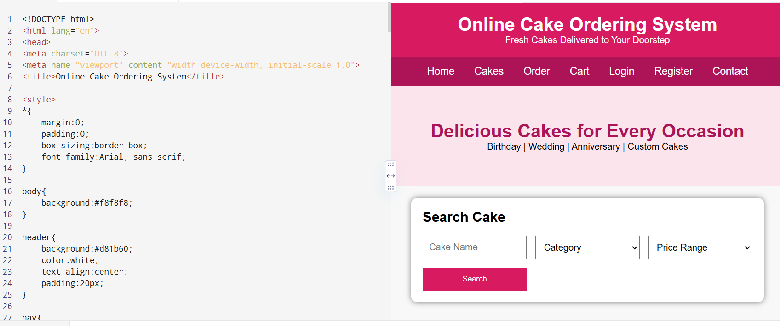

7) PROGRAM
<!DOCTYPE html>
<html lang="en">
<head>
<meta charset="UTF-8">
<meta name="viewport" content="width=device-width, initial-scale=1.0">
<title>Beauty Parlour Appointment Booking System</title>

<style>

*{
margin:0;
padding:0;
box-sizing:border-box;
font-family:Arial,sans-serif;
}

body{
background:#f8f8f8;
}

header{
background:#e91e63;
color:white;
text-align:center;
padding:20px;
}

nav{
background:#c2185b;
padding:15px;
text-align:center;
}

nav a{
color:white;
text-decoration:none;
margin:15px;
font-size:18px;
}

nav a:hover{
color:yellow;
}

.hero{
background:#fce4ec;
text-align:center;
padding:60px;
}

.hero h1{
color:#c2185b;
}

.search{
width:90%;
max-width:1000px;
background:white;
margin:20px auto;
padding:20px;
border-radius:10px;
box-shadow:0 0 10px gray;
}

form{
display:grid;
grid-template-columns:repeat(auto-fit,minmax(180px,1fr));
gap:15px;
}

input,select{
padding:10px;
font-size:16px;
}

button{
background:#e91e63;
color:white;
border:none;
padding:12px;
cursor:pointer;
}

button:hover{
background:#ad1457;
}

.section{
padding:30px;
}

.cards{
display:flex;
flex-wrap:wrap;
justify-content:center;
gap:20px;
}

.card{
width:250px;
background:white;
border-radius:10px;
box-shadow:0 0 10px #ccc;
text-align:center;
padding:20px;
}

.card img{
width:100%;
border-radius:10px;
}

.card h3{
color:#e91e63;
}

footer{
background:#c2185b;
color:white;
text-align:center;
padding:20px;
}

</style>

</head>

<body>

<header>

<h1>Beauty Parlour Appointment Booking System</h1>

<p>Book Your Beauty Appointment Online</p>

</header>

<nav>

<a href="#">Home</a>
<a href="#">Services</a>
<a href="#">Stylists</a>
<a href="#">Appointments</a>
<a href="#">Login</a>
<a href="#">Register</a>
<a href="#">Contact</a>

</nav>

<section class="hero">

<h1>Look Beautiful Every Day</h1>

<p>Book Beauty Services Anytime, Anywhere</p>

</section>

<div class="search">

<h2>Book Appointment</h2>

<br>

<form>

<input type="text" placeholder="Customer Name">

<select>
<option>Select Service</option>
<option>Hair Cut</option>
<option>Hair Spa</option>
<option>Facial</option>
<option>Bridal Makeup</option>
<option>Pedicure</option>
<option>Manicure</option>
</select>

<select>
<option>Select Stylist</option>
<option>Priya</option>
<option>Anjali</option>
<option>Divya</option>
<option>Sneha</option>
</select>

<input type="date">

<input type="time">

<button>Book Appointment</button>

</form>

</div>

<section class="section">

<h2 align="center">Our Beauty Services</h2>

<br>

<div class="cards">

<div class="card">

<img src="https://via.placeholder.com/220x150">

<h3>Hair Styling</h3>

<p>Professional Hair Styling</p>

<button>Book Now</button>

</div>

<div class="card">

<img src="https://via.placeholder.com/220x150">

<h3>Facial</h3>

<p>Skin Care Treatment</p>

<button>Book Now</button>

</div>

<div class="card">

<img src="https://via.placeholder.com/220x150">

<h3>Bridal Makeup</h3>

<p>Complete Bridal Package</p>

<button>Book Now</button>

</div>

<div class="card">

<img src="https://via.placeholder.com/220x150">

<h3>Manicure & Pedicure</h3>

<p>Nail Care Services</p>

<button>Book Now</button>

</div>

</div>

</section>

<section class="section">

<h2>Customer Features</h2>

<ul>

<li>✔ Register & Login</li>
<li>✔ View Services</li>
<li>✔ View Stylist Profiles</li>
<li>✔ Check Available Slots</li>
<li>✔ Book Appointment</li>
<li>✔ Upcoming Reservations</li>
<li>✔ Reservation History</li>
<li>✔ Cancel Appointment</li>
<li>✔ Reschedule Appointment</li>
<li>✔ Online Payment</li>
<li>✔ Personal Profile</li>
<li>✔ Leave Feedback</li>

</ul>

</section>

<section class="section">

<h2>Salon Manager Features</h2>

<ul>

<li>✔ Admin Login</li>
<li>✔ Reservation Calendar</li>
<li>✔ Add Reservation</li>
<li>✔ Edit Reservation</li>
<li>✔ Cancel Reservation</li>
<li>✔ Lock Unavailable Hours</li>
<li>✔ Manage Services</li>
<li>✔ Manage Stylists</li>
<li>✔ Send SMS Reminder</li>
<li>✔ Manage Customer Accounts</li>
<li>✔ Accept Online Payments</li>
<li>✔ Automatic Cancellation of Unpaid Reservations</li>

</ul>

</section>

<section class="section">

<h2>Customer Feedback</h2>

<textarea rows="5" cols="70" placeholder="Write your feedback here..."></textarea>

<br><br>

<button>Submit Feedback</button>

</section>

<section class="section">

<h2>Contact Us</h2>

<p>Email : support@beautyparlour.com</p>

<p>Phone : +1 9876543210</p>

<p>Address : Beauty Parlour, Main Street</p>

</section>

<footer>

<p>© 2026 Beauty Parlour Appointment Booking System | All Rights Reserved</p>

</footer>

</body>
</html>
OUTPUT:
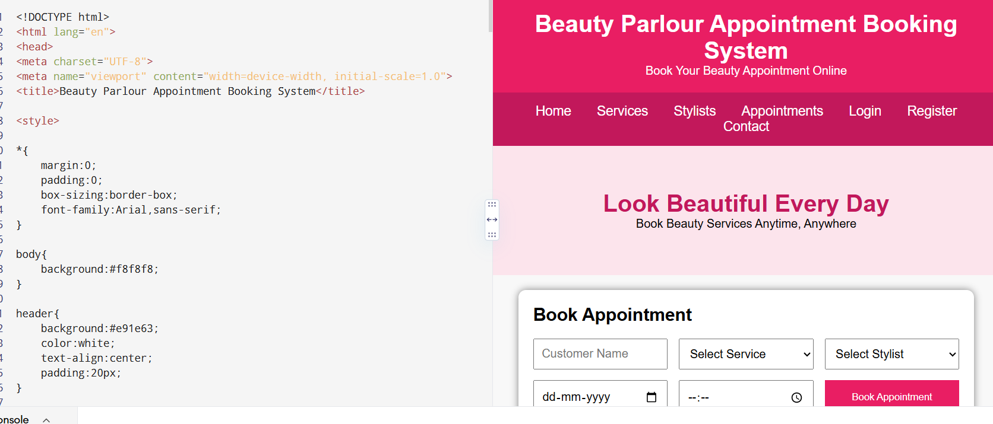

8)PROGRAM
<!DOCTYPE html>
<html lang="en">
<head>
<meta charset="UTF-8">
<meta name="viewport" content="width=device-width, initial-scale=1.0">
<title>MedCare Hospital Appointment Booking</title>

<style>
*{
margin:0;
padding:0;
box-sizing:border-box;
font-family:Arial, sans-serif;
}

body{
background:#f2f7fb;
}

header{
background:#1976d2;
color:white;
text-align:center;
padding:20px;
}

nav{
background:#1565c0;
padding:15px;
text-align:center;
}

nav a{
color:white;
text-decoration:none;
margin:15px;
font-size:18px;
}

nav a:hover{
color:yellow;
}

.hero{
background:#e3f2fd;
padding:60px;
text-align:center;
}

.hero h1{
color:#1565c0;
}

.search{
width:90%;
max-width:1000px;
margin:20px auto;
background:white;
padding:20px;
border-radius:10px;
box-shadow:0 0 10px gray;
}

form{
display:grid;
grid-template-columns:repeat(auto-fit,minmax(180px,1fr));
gap:15px;
}

input,select{
padding:10px;
font-size:16px;
}

button{
background:#1976d2;
color:white;
border:none;
padding:12px;
cursor:pointer;
}

button:hover{
background:#0d47a1;
}

.section{
padding:30px;
}

.cards{
display:flex;
flex-wrap:wrap;
justify-content:center;
gap:20px;
}

.card{
width:250px;
background:white;
padding:20px;
border-radius:10px;
box-shadow:0 0 10px #ccc;
text-align:center;
}

.card h3{
color:#1976d2;
margin-bottom:10px;
}

footer{
background:#1565c0;
color:white;
text-align:center;
padding:20px;
margin-top:20px;
}
</style>

</head>

<body>

<header>

<h1>MedCare Hospital Appointment Booking System</h1>

<p>Book Doctor Appointments Online</p>

</header>

<nav>

<a href="#">Home</a>
<a href="#">Hospitals</a>
<a href="#">Doctors</a>
<a href="#">Appointments</a>
<a href="#">Login</a>
<a href="#">Register</a>
<a href="#">Contact</a>

</nav>

<section class="hero">

<h1>Find the Right Doctor</h1>

<p>Search Hospitals and Book Appointments Easily</p>

</section>

<div class="search">

<h2>Search Doctor</h2>

<br>

<form>

<input type="text" placeholder="Location">

<select>
<option>Select Specialty</option>
<option>Cardiologist</option>
<option>Dermatologist</option>
<option>Orthopedic</option>
<option>Pediatrician</option>
<option>Neurologist</option>
</select>

<input type="date">

<button>Search</button>

</form>

</div>

<section class="section">

<h2 align="center">Available Doctors</h2>

<br>

<div class="cards">

<div class="card">
<h3>Dr. John Smith</h3>
<p>Cardiologist</p>
<p>City Hospital</p>
<button>Book Appointment</button>
</div>

<div class="card">
<h3>Dr. Priya Sharma</h3>
<p>Dermatologist</p>
<p>MedCare Hospital</p>
<button>Book Appointment</button>
</div>

<div class="card">
<h3>Dr. David Lee</h3>
<p>Orthopedic</p>
<p>Sunrise Hospital</p>
<button>Book Appointment</button>
</div>

<div class="card">
<h3>Dr. Anjali Rao</h3>
<p>Pediatrician</p>
<p>LifeCare Hospital</p>
<button>Book Appointment</button>
</div>

</div>

</section>

<section class="section">

<h2>Patient Features</h2>

<ul>
<li>✔ Signup / Login</li>
<li>✔ Search Doctors by Specialty</li>
<li>✔ Search Hospitals by Location</li>
<li>✔ Book Appointment</li>
<li>✔ Cancel Appointment</li>
<li>✔ Appointment History</li>
<li>✔ Check-in Form</li>
<li>✔ View Appointment Status</li>
<li>✔ Update Personal Details</li>
<li>✔ View Hospital Location (Google Maps)</li>
<li>✔ Rate and Review Doctors</li>
</ul>

</section>

<section class="section">

<h2>Hospital Features</h2>

<ul>
<li>✔ Hospital Registration</li>
<li>✔ Hospital Login</li>
<li>✔ Create Hospital Profile</li>
<li>✔ Update Hospital Details</li>
<li>✔ Update Hospital Location</li>
<li>✔ Manage Doctors</li>
<li>✔ Manage Appointments</li>
</ul>

</section>

<section class="section">

<h2>Administrator Features</h2>

<ul>
<li>✔ Manage Doctors</li>
<li>✔ Manage Appointments</li>
<li>✔ Appointment Statistics</li>
<li>✔ Rating Details</li>
<li>✔ Manage Hospitals</li>
<li>✔ Manage Patients</li>
</ul>

</section>

<section class="section">

<h2>Patient Feedback</h2>

<textarea rows="5" cols="70" placeholder="Write your review here..."></textarea>

<br><br>

<button>Submit Review</button>

</section>

<section class="section">

<h2>Contact Us</h2>

<p>Email: support@medcarehospital.com</p>

<p>Phone: +1 9876543210</p>

<p>Address: MedCare Hospital, Main City</p>

</section>

<footer>

<p>© 2026 MedCare Hospital Appointment Booking System | All Rights Reserved</p>

</footer>

</body>
</html>
OUTPUT:
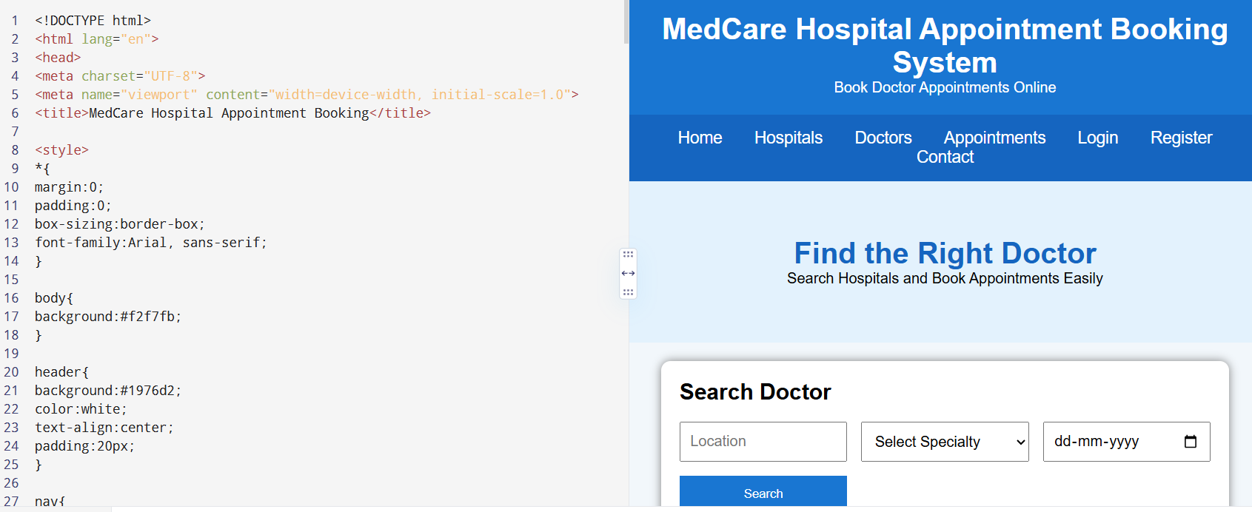

9)PROGRAM
<!DOCTYPE html>
<html lang="en">
<head>
<meta charset="UTF-8">
<meta name="viewport" content="width=device-width, initial-scale=1.0">
<title>TechSavvy Online Shopping</title>

<style>

*{
margin:0;
padding:0;
box-sizing:border-box;
font-family:Arial, sans-serif;
}

body{
background:#f4f4f4;
}

header{
background:#0d47a1;
color:white;
text-align:center;
padding:20px;
}

nav{
background:#1565c0;
padding:15px;
text-align:center;
}

nav a{
color:white;
text-decoration:none;
margin:15px;
font-size:18px;
}

nav a:hover{
color:yellow;
}

.hero{
background:#e3f2fd;
text-align:center;
padding:60px;
}

.hero h1{
color:#0d47a1;
}

.search{
width:90%;
max-width:1000px;
margin:20px auto;
background:white;
padding:20px;
border-radius:10px;
box-shadow:0 0 10px gray;
}

form{
display:grid;
grid-template-columns:repeat(auto-fit,minmax(180px,1fr));
gap:15px;
}

input,select{
padding:10px;
font-size:16px;
}

button{
background:#1565c0;
color:white;
border:none;
padding:12px;
cursor:pointer;
}

button:hover{
background:#0d47a1;
}

.section{
padding:30px;
}

.cards{
display:flex;
flex-wrap:wrap;
justify-content:center;
gap:20px;
}

.card{
width:250px;
background:white;
border-radius:10px;
box-shadow:0 0 10px #ccc;
text-align:center;
padding:20px;
}

.card img{
width:100%;
height:180px;
}

.card h3{
color:#1565c0;
margin:10px;
}

.card p{
margin:5px;
}

footer{
background:#1565c0;
color:white;
text-align:center;
padding:20px;
margin-top:20px;
}

</style>

</head>

<body>

<header>

<h1>TechSavvy Online Shopping</h1>

<p>Electronics Shopping Made Easy</p>

</header>

<nav>

<a href="#">Home</a>
<a href="#">Products</a>
<a href="#">Categories</a>
<a href="#">Cart</a>
<a href="#">Wishlist</a>
<a href="#">Login</a>
<a href="#">Register</a>
<a href="#">Contact</a>

</nav>

<section class="hero">

<h1>Latest Electronic Gadgets</h1>

<p>Smartphones • Laptops • Tablets • Accessories</p>

</section>

<div class="search">

<h2>Search Products</h2>

<br>

<form>

<input type="text" placeholder="Search Product">

<select>

<option>Category</option>

<option>Smartphones</option>

<option>Laptops</option>

<option>Tablets</option>

<option>Headphones</option>

<option>Smart Watches</option>

</select>

<select>

<option>Price Range</option>

<option>Under $100</option>

<option>$100 - $500</option>

<option>$500 - $1000</option>

<option>Above $1000</option>

</select>

<button>Search</button>

</form>

</div>

<section class="section">

<h2 align="center">Popular Products</h2>

<br>

<div class="cards">

<div class="card">

<img src="https://via.placeholder.com/220x180">

<h3>Smartphone</h3>

<p>Price: $699</p>

<button>Add to Cart</button>

</div>

<div class="card">

<img src="https://via.placeholder.com/220x180">

<h3>Laptop</h3>

<p>Price: $999</p>

<button>Add to Cart</button>

</div>

<div class="card">

<img src="https://via.placeholder.com/220x180">

<h3>Tablet</h3>

<p>Price: $499</p>

<button>Add to Cart</button>

</div>

<div class="card">

<img src="https://via.placeholder.com/220x180">

<h3>Wireless Headphones</h3>

<p>Price: $149</p>

<button>Add to Cart</button>

</div>

</div>

</section>

<section class="section">

<h2>Customer Features</h2>

<ul>

<li>✔ User Registration & Login</li>

<li>✔ Search Products</li>

<li>✔ Browse Categories</li>

<li>✔ Check Product Availability</li>

<li>✔ View Product Details</li>

<li>✔ Add to Cart</li>

<li>✔ Edit Shopping Cart</li>

<li>✔ Remove Items from Cart</li>

<li>✔ Checkout</li>

<li>✔ Track Order Status</li>

<li>✔ Order History</li>

<li>✔ Wishlist</li>

</ul>

</section>

<section class="section">

<h2>Administrator Features</h2>

<ul>

<li>✔ Admin Login</li>

<li>✔ Add Products</li>

<li>✔ Remove Products</li>

<li>✔ Update Product Price</li>

<li>✔ Update Product Description</li>

<li>✔ Manage Categories</li>

<li>✔ View Customer Orders</li>

<li>✔ Generate Reports</li>

</ul>

</section>

<section class="section">

<h2>Customer Reviews</h2>

<textarea rows="5" cols="70" placeholder="Write your review here..."></textarea>

<br><br>

<button>Submit Review</button>

</section>

<section class="section">

<h2>Contact Us</h2>

<p>Email: support@techsavvy.com</p>

<p>Phone: +1 9876543210</p>

<p>Address: TechSavvy Electronics Store</p>

</section>

<footer>

<p>© 2026 TechSavvy Online Shopping | All Rights Reserved</p>

</footer>

</body>
</html>
OUTPUT:
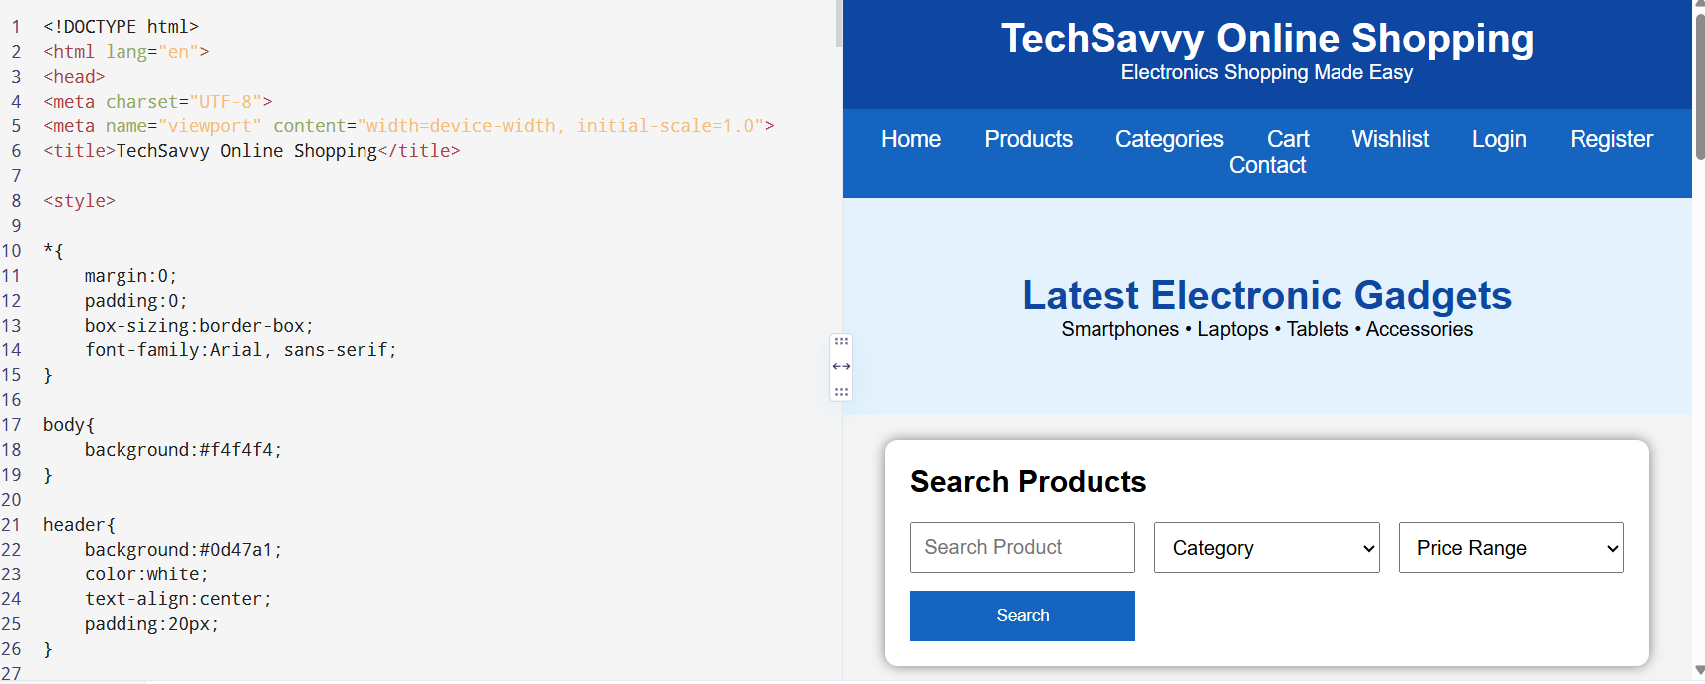

10)PROGRAM
<!DOCTYPE html>
<html lang="en">
<head>
<meta charset="UTF-8">
<meta name="viewport" content="width=device-width, initial-scale=1.0">
<title>StyleHub - Online Fashion Store</title>

<style>

*{
margin:0;
padding:0;
box-sizing:border-box;
font-family:Arial, Helvetica, sans-serif;
}

body{
background:#f5f5f5;
}

header{
background:#8e24aa;
color:white;
text-align:center;
padding:20px;
}

nav{
background:#6a1b9a;
padding:15px;
text-align:center;
}

nav a{
color:white;
text-decoration:none;
margin:15px;
font-size:18px;
}

nav a:hover{
color:yellow;
}

.hero{
background:#f3e5f5;
padding:60px;
text-align:center;
}

.hero h1{
color:#6a1b9a;
}

.search-box{
width:90%;
max-width:1000px;
margin:20px auto;
background:white;
padding:20px;
border-radius:10px;
box-shadow:0 0 10px gray;
}

form{
display:grid;
grid-template-columns:repeat(auto-fit,minmax(180px,1fr));
gap:15px;
}

input,select{
padding:10px;
font-size:16px;
}

button{
background:#8e24aa;
color:white;
border:none;
padding:12px;
cursor:pointer;
}

button:hover{
background:#4a148c;
}

.section{
padding:30px;
}

.cards{
display:flex;
flex-wrap:wrap;
justify-content:center;
gap:20px;
}

.card{
width:250px;
background:white;
border-radius:10px;
box-shadow:0 0 10px #ccc;
text-align:center;
padding:15px;
}

.card img{
width:100%;
height:220px;
border-radius:8px;
}

.card h3{
color:#8e24aa;
margin:10px 0;
}

footer{
background:#6a1b9a;
color:white;
text-align:center;
padding:20px;
margin-top:20px;
}

</style>

</head>

<body>

<header>

<h1>StyleHub Fashion Store</h1>

<p>Shop the Latest Fashion Trends</p>

</header>

<nav>

<a href="#">Home</a>
<a href="#">Men</a>
<a href="#">Women</a>
<a href="#">Kids</a>
<a href="#">Accessories</a>
<a href="#">Cart</a>
<a href="#">Wishlist</a>
<a href="#">Login</a>
<a href="#">Register</a>

</nav>

<section class="hero">

<h1>Fashion for Everyone</h1>

<p>Clothing • Footwear • Accessories</p>

</section>

<div class="search-box">

<h2>Search Products</h2>

<br>

<form>

<input type="text" placeholder="Search Product">

<select>

<option>Select Category</option>

<option>Men</option>

<option>Women</option>

<option>Kids</option>

<option>Accessories</option>

</select>

<select>

<option>Select Price</option>

<option>Under $50</option>

<option>$50 - $100</option>

<option>$100 - $200</option>

<option>Above $200</option>

</select>

<button>Search</button>

</form>

</div>

<section class="section">

<h2 align="center">Popular Categories</h2>

<br>

<div class="cards">

<div class="card">
<img src="https://via.placeholder.com/220x220">
<h3>Men's Wear</h3>
<p>Casual & Formal</p>
<button>Shop Now</button>
</div>

<div class="card">
<img src="https://via.placeholder.com/220x220">
<h3>Women's Wear</h3>
<p>Latest Collections</p>
<button>Shop Now</button>
</div>

<div class="card">
<img src="https://via.placeholder.com/220x220">
<h3>Kids Fashion</h3>
<p>Comfortable Clothing</p>
<button>Shop Now</button>
</div>

<div class="card">
<img src="https://via.placeholder.com/220x220">
<h3>Accessories</h3>
<p>Bags, Watches & More</p>
<button>Shop Now</button>
</div>

</div>

</section>

<section class="section">

<h2>Customer Features</h2>

<ul>

<li>✔ User Registration & Login</li>
<li>✔ Browse Products</li>
<li>✔ Search & Filter Products</li>
<li>✔ View Product Details</li>
<li>✔ Check Product Availability</li>
<li>✔ Add to Shopping Cart</li>
<li>✔ Edit Shopping Cart</li>
<li>✔ Remove Items from Cart</li>
<li>✔ Wishlist</li>
<li>✔ Checkout</li>
<li>✔ Secure Payment</li>
<li>✔ Track Orders</li>
<li>✔ Order History</li>
<li>✔ Returns & Exchange</li>

</ul>

</section>

<section class="section">

<h2>Administrator Features</h2>

<ul>

<li>✔ Admin Login</li>
<li>✔ Add Products</li>
<li>✔ Remove Products</li>
<li>✔ Update Product Price</li>
<li>✔ Update Product Description</li>
<li>✔ Manage Categories</li>
<li>✔ Manage Customer Orders</li>
<li>✔ View Customer Information</li>
<li>✔ Manage Discounts</li>

</ul>

</section>

<section class="section">

<h2>Customer Reviews</h2>

<textarea rows="5" cols="70" placeholder="Write your review here..."></textarea>

<br><br>

<button>Submit Review</button>

</section>

<section class="section">

<h2>Contact Us</h2>

<p>Email : support@stylehub.com</p>

<p>Phone : +1 9876543210</p>

<p>Address : StyleHub Fashion Store</p>

</section>

<footer>

<p>© 2026 StyleHub Online Fashion Store | All Rights Reserved</p>

</footer>

</body>
</html>
OUTPUT:
